Assignment 6 (October 10 - 16)

1. Consider the equation 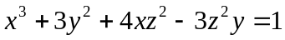. Does this equation define z as a function of x and y:
a) In a neighborhood of x=1, y=1?
b) In a neighborhood of x=1, y=0?
c) In a neighborhood of x=0.5, y=0? If so, compute 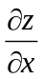 and 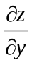 at this point.

2. Consider 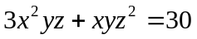 as defining x as an implicit function of y and z around the point x=1, y=3, z=2.
If y increases to 3.2 and z remains at 2, use the Implicit Function Theorem to estimate the corresponding x.

3. Calculate the first and the second order derivatives of an implicit function y(x) given by an equation 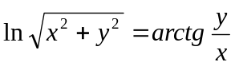.

4. Calculate the first and the second order derivatives of an implicit function y(x) given by an equation 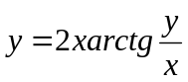

5. Find all partial derivatives of the first and second order of the composite function 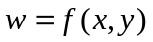, where 